Permission file
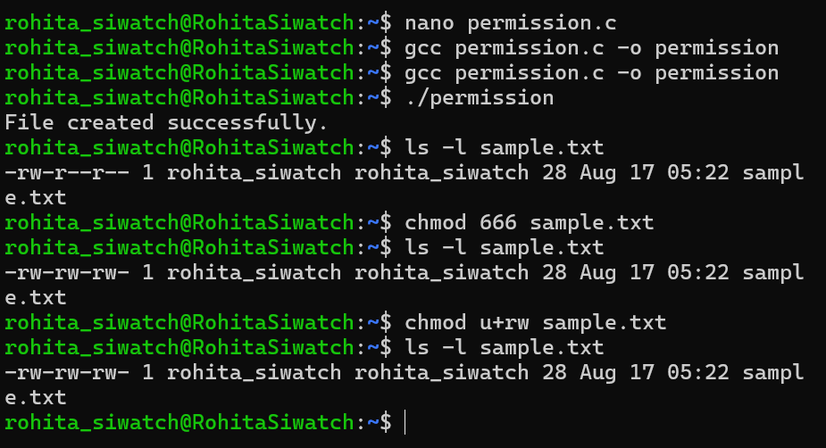
Task – 1
Give Read and Write only to the owner
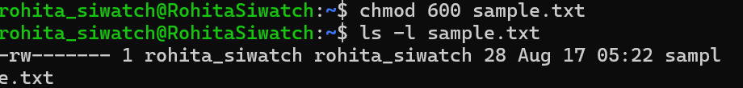
Task – 2
Give Read and Write to the owner and group
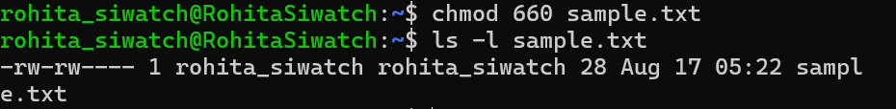
Task – 3
Only owner can read and write
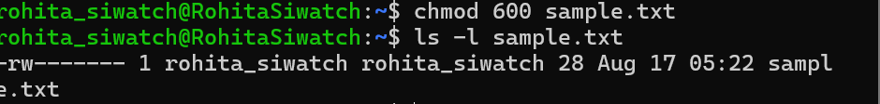

Task – 4
Owner read/write, everyone else read-only
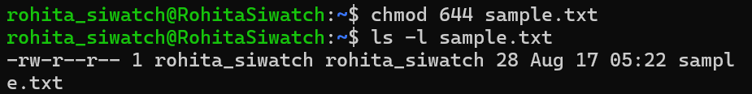
Task – 5
Owner can do everything, others can only read and execute
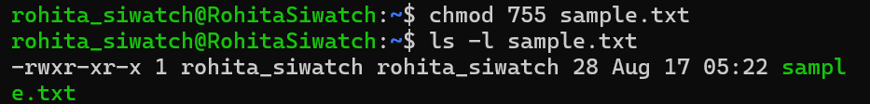
Task – 6
Owner and group can read/write
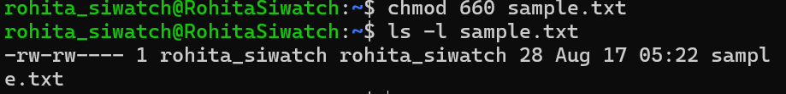
Task – 7
Only owner can execute
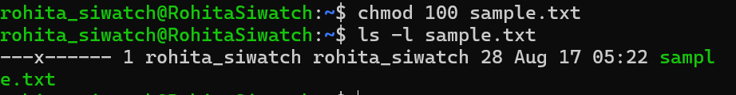

8) Owner: read + write; Group: nothing; Others: nothing → 600
9) Owner: read + write; Group: read; Others: read → 644
10) Owner: read + write + execute; Group: read + execute; Others: read + execute → 755
11) Owner: read + write; Group: read + write; Others: nothing → 660
12) Everyone: read only → 444

